## Lab 3

Question 1

1/1 point (graded)

Which three fields are available when creating a Pie chart for visualization?

Legend

Group

Details

Values

Question 2

1/1 point (graded)

Consider the following chart:

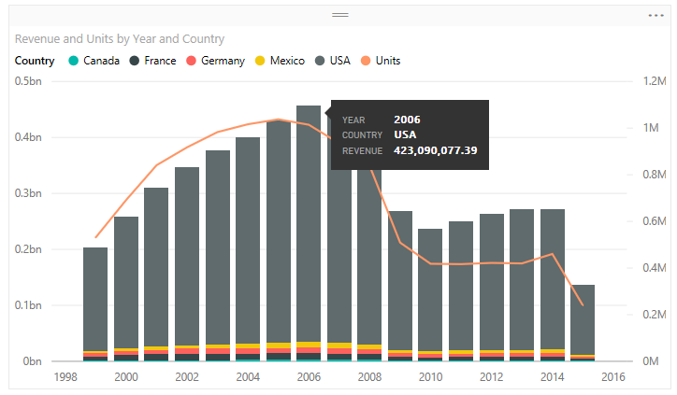

Drag and drop the fields to the corresponding settings to create the above chart.

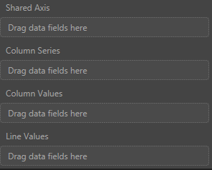

Question 3

1/1 point (graded)

By default, which level of filter behaves the same as a slicer in a report in Power BI Desktop

Visual level filter

Page level filter

Report level filter

Query level filter

Question 4

1/1 point (graded)

Consider the following chart:

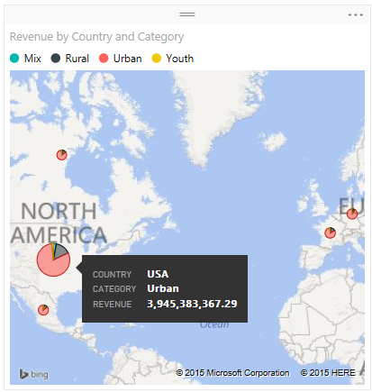

Drag and drop the fields to the corresponding settings to create the above chart.

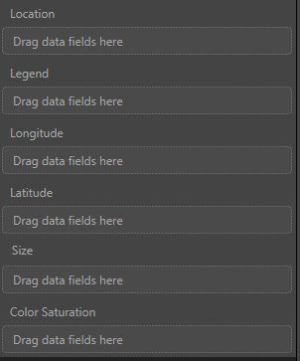

Question 5

1/1 point (graded)

Consider the following chart:

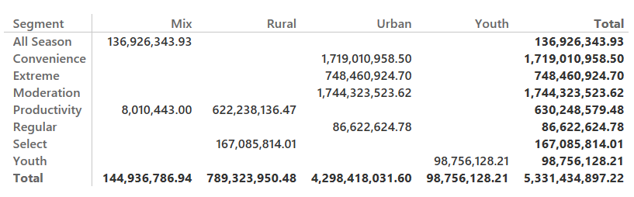

Drag and drop the fields to the corresponding settings to create the above chart.

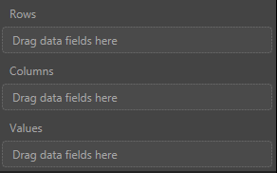

Question 6

1/1 point (graded)

When creating a waterfall chart, which two field options that you need to define?

Category

X Axis

Y Axis

Size

Question 7

1/1 point (graded)

Which visualization would you use to show progress toward a particular target?

Bar chart

Scatter chart

Waterfall

Gauge

Question 8

1/1 point (graded)

Which of the following shapes are three of the shapes that you can create using the Insert Shapes feature in Power BI Desktop?

Flowchart

Triangle

Rectangle

Oval